# The VCF format provides efficient and robust storage of GWAS summary statistics

Matthew Lyon1,2*, Shea J Andrews3*, Ben Elsworth2, Tom R Gaunt1,2, Gibran Hemani2¥, Edoardo Marcora3¥

* Joint first author

¥ Joint last author

Correspondence: Matthew Lyon (matt.lyon@bristol.ac.uk; ORCID 0000-0002-2500-1013)

1. National Institute for Health Research Bristol Biomedical Research Centre, University of Bristol, Bristol, UK
2. Medical Research Council (MRC) Integrative Epidemiology Unit (IEU), Bristol Medical School (Population Health Sciences), University of Bristol, Bristol, UK
3. Ronald M. Loeb Center for Alzheimer’s disease, Department of Neuroscience, Icahn School of Medicine at Mount Sinai, New York, NY, USA

Author contributions:

* All authors contributed the manuscript and storage format specification
* GH and EM conceived idea
* ML and GH wrote software packages and performed performance simulations
* BE and GH prepared the GWAS data

Conflict of interest: None

## Abstract

Genome-wide association study (GWAS) summary statistics are a fundamental resource for a variety of research applications. Yet despite their widespread utility, no common storage format has been widely adopted, hindering tool development, data sharing, secondary analysis and data integration. Existing tabular formats ambiguously and often incompletely store information about variants and their associations and also lack essential metadata, thus increasing the possibility of errors in data interpretation and post-GWAS analyses. Additionally, data in these formats are typically not indexed, requiring the whole file be read to extract specific variant-trait associations which is slow and computationally inefficient. To address these issues, we propose a solution using the variant call format (VCF) and a suite of open-source tools for creating and using the format in downstream analyses. Simulations of query performance using tabix and standard UNIX tools demonstrate VCF is 8.6-45.5x faster than tabular alternatives when extracting variant(s) by genomic position. To encourage adoption, we provide free access to over 10,000 complete GWAS summary datasets that have been converted to this format (available from: <https://gwas.mrcieu.ac.uk>).

## Introduction

The GWAS is a powerful tool for identifying genetic loci associated with any trait, including diseases and clinical biomarkers, as well as non-clinical and molecular phenotypes such as height and gene expression (eQTLs) [1]. Sharing of GWAS results as summary statistics (i.e. variant, effect size, standard error, p-value etc) has enabled a range of important secondary research applications including: causal gene and functional variant prioritization [2], causal cell/tissue type nomination [3], investigation of biological mechanisms and pathways [1], causal inference (Mendelian randomization; MR) [4], risk prediction [1], genetic correlation [5] and heritability estimation [6]. However, the utility of GWAS summary statistics is hampered by the absence of a universally adopted storage format and associated tools.

Historic lack of a common standard has led to GWAS analysis tools outputting results in different formats (e.g. plink [7], GCTA [8], BOLT-LMM [9], GEMMA [10] and meta-analysis tools e.g. METAL [11]). As a consequence, various processing issues are typically encountered during secondary analysis. First, inconsistency and ambiguity of which allele relates to the effect size estimate (the “effect” allele). Confusion over the effect allele can have disastrous consequences on the interpretation of GWAS findings and the validity of post-GWAS analyses. For example MR studies may provide causal estimates with incorrect effect directionality [12]. Likewise, prediction models based on polygenic risk scores might predict disease groups wrongly or suffer reduced power if some of the effect directionalities are incorrect. Related issues are encountered with naïve usage of dbSNP [13] identifiers which uniquely identify the variant base-position but do not distinguish between multiple alternative alleles. Second, summary statistics files are provided with a variety of content and field (column) names. Absent fields can severely limit some analyses, and although approaches exist to estimate the values of some of these missing columns (e.g. standard error from P value) imprecision is introduced reducing power. Varying field names are easily addressed in principle but can be cumbersome and error prone. Third, data are frequently distributed with no or insufficient metadata describing the trait, measurement units, publication source, etc. which can lead to errors and impede research reproducibility. Fourth, querying plain text tabular files is slow and memory inefficient, making some potential applications computationally infeasible (e.g. systematic hypothesis-free analyses).

Some proposals for a standard format have been made. The EBI-NHGRI GWAS catalog developed a text format with uniform column names [14]. The SMR tool [15] introduced a binary format for rapid querying of quantitative trait loci. These approaches are adequate for storing variant level summary statistics but do not enforce allele consistency or have sufficient capacity for essential metadata. Learning from these examples, our own experiences processing GWAS data across two research centers and considering future needs i.e. GWAS of rare variants using genome sequencing, we developed a set of requirements for a suitable universal format.

We determined that adapting the widely used variant call format (VCF) [16], [17] was a convenient and constructive approach to meet these requirements. Here we outline the implementation, explain how it meets these requirements, describe existing and new software that creates and connects to the data format, and show results of query performance. Finally, we provide access to over 10,000 complete GWAS summary datasets that have been converted to this format as part of the IEU GWAS database, and are freely available for download: <https://gwas.mrcieu.ac.uk>.

## Results

### Storage format specification

We developed a set of requirements for an optimal GWAS summary statistics storage format that addresses our needs of performing high-throughput secondary analyses (Table 1). These requirements focus on consistent and robust storage of genetic association data, capacity for metadata to provide a full audit trail, efficient querying and storage, ensuring file integrity, interoperability with existing open-source tools and across multiple datasets for data sharing and integration. For each requirement we provide evidence to demonstrate how the VCF format meets these needs and showcase capabilities of this storage format (Table 1).

### Query performance of GWAS-VCF format

We evaluated runtime performance of querying GWAS summary statistics in VCF and unindexed text through simulation studies with five repetitions using a range of common operations.

The fastest mean runtime to extract a single variant by dbSNP identifier (Figure 2) was 0.09 seconds (95% CI 0.09, 0.10) for compressed VCF indexed with rsidx [24]. The second-best performer was 8.6 times slower at 0.78 seconds (95% 0.68, 0.89) using UNIX grep on uncompressed plain text.

Compressed VCF was also quickest to retrieve a single record by chromosome position (Figure 3; mean runtime 0.08 seconds [95% CI 0.07, 0.08]) compared with the second-best performer using UNIX grep on uncompressed plain text which was 21 times slower (mean runtime 1.71 seconds [95% CI 1.58, 1.84]).

The lowest mean runtime to extract variants within a 1 Mb interval (Figure 4) was for compressed VCF (mean query time 0.10 seconds [95% CI 0.09, 0.10]). Using unindexed text, the best performer was for UNIX AWK using an uncompressed file, which was 45.5 times slower (mean query time 4.55 seconds [95% CI 4.46, 4.63]).

Finally, we evaluated methods to select variants by association P value (Figure 5). The fastest mean query took 6.19 seconds (95% CI 5.62, 6.76) using AWK on uncompressed text. Meanwhile, bcftools took an average of 39.29 seconds (95% CI 34.25, 44.33) using compressed VCF. We also evaluated the binary call format (BCF) using bcftools which took an average of 15.1 seconds (95% CI 10.87, 19.33).

## Discussion

We introduced an adaptation of the well-established and widely-used VCF format for storing GWAS summary statistics. This approach has many advantages over existing solutions: provides established methods for handling complex variation (multiallelic and insertion-deletion variants), format validation to ensure data integrity, embedding of study/variant/trait-level metadata, compatibility with existing open-source tools, human readable, compressed and rapid to query.

Simulations of query performance suggest VCF is substantially quicker than unindexed and uncompressed flat files for querying by position. Although extracting variants by association P value threshold was quicker using UNIX tools, this could be improved by using INFO field flags to highlight variants below prespecified thresholds if the exact value is unimportant. For example, all variants at genome-wide significance (P=5e-8) or a more relaxed threshold (e.g. P=5e-5). Alternatively, VCF files could be read entirely into memory if possible or loaded into a dedicated database such as GenomicsDB [26] which might offer better query performance.

To encourage adoption, we developed various open-source tools: for mapping tabular data to VCF including a web interface, libraries for reading GWAS-VCF files using R or Python3 and processing data for secondary analysis using R (Table 2). Additionally, we made available over 10,000 complete GWAS summary statistics in VCF format (links below). We encourage users to provide feedback via the relevant repository issue page.

## Method

### Specification

The specification (available from: <https://github.com/MRCIEU/gwas-vcf-spec/releases/tag/1.0.0>) was developed through experience of collecting and harmonising GWAS summary data across two research centres at scale [18] and performing a range of representative high throughput analyses on these data (for example LD score regression [19], MR [20], genetic colocalization analysis [21] and polygenic risk scores [22]).

### Implementation

The VCF format is organized into three components: a flexible file header containing meta-data (lines beginning with ‘#’), variant information (one locus per row) and sample information (one sample per column). We adapt this format to include GWAS-specific metadata (Supplementary Table 1) and utilise the sample column to store variant-trait association data (Figure 1; Supplementary Table 2).

The VCF header is mandatory for defining fields throughout the file body including variable description, value requirements (i.e. number of values permitted and null values) and data type (i.e. string, number and boolean). Metadata define important characteristics of the GWAS: trait description(s), units and identifiers, genome build, chromosome lengths and number, number of variants, type of trait (continuous or binary), sample size and study identifier.

Each row of the file body contains a single variant position including chromosome name, base-pair position, variant identifier (i.e. dbSNP identifier), reference (non-effect allele), alternative/effect allele(s), quality field and filter which can be used to flag poor quality variants for exclusion in downstream analyses. The INFO column is a flexible store for variant-level data such as population frequency, genomic annotations and functional effects. Finally, the sample column is used to store allele-trait association metrics: effect size, standard error, association P-value, analysis cohort allele frequency and GWAS marker identifier.

### Gwas2VCF

To automate mapping tabular GWAS summary statistics to VCF, we developed open-source Python3 software (gwas2vcf; <https://github.com/MRCIEU/gwas2vcf>) that may be run natively on UNIX systems or using Docker (DockerHub mrcieu/gwas2vcf).

The application reads in GWAS data using a user-defined file schema requiring as a minimum: chromosome name and position, effect and non-effect alleles, effect size (beta or log-odds), standard error and association P value. Each variant is aligned to a user-supplied reference genome file (FASTA; obtained from Ensembl or UCSC) and harmonized to ensure the reference allele matches the non-effect allele and the effect allele is non-reference. Variants not matching the supplied FASTA are discarded. Variant counts during each step are retained for audit and diagnostic purposes. Thereafter records are sorted karyotypically and written along with metadata to a single BGZIP [23] compressed VCF file. Insertion-deletions are left-aligned, trimmed and normalized before merging rows with the same chromosome position into a single record using bcftools (‘norm’ command). Finally, the VCF is indexed using tabix [23] and rsidx [24] enabling rapid queries by genomic position and dbSNP identifier, respectively.

We have also developed a web application to provide a user-friendly interface for this implementation available from: <http://64.227.44.193>. The user is required to provide metadata via a webform and upload a single GWAS file for processing. Upon successful upload a unique job identifier is returned. Processing may take 30 minutes to one hour depending on file size and resource usage. The user may check the status of their job and download processed data using a separate webform.

Tools for reading, querying and manipulating GWAS-VCF files have also been developed for R and Python3 (Table 2).

### Query performance simulation

Densely imputed summary statistics (13,791,467 variants) for a large GWAS of body mass index data were obtained from the IEU GWAS database, part of MR-Base [25]. The data were mapped to VCF using Gwas2VCF v1.1.1 and processed using bcftools v1.10 [23] to remove multiallelic variants or records with missing dbSNP identifiers. A tabular (unindexed) file was prepared from the VCF to replicate a typical storage medium currently used for distributing summary statistics. Query runtime performance was compared between tabix and standard UNIX commands under the following conditions: single variant selection using dbSNP identifier or chromosome position, multi-variant selection by association P value (thresholds: P < 5e-8, 0.2, 0.4, 0.6, 0.8) or 1 Mb genomic interval. Tests were undertaken with five repetitions using VCF or unindexed text formats with and without GZIP compression on an Ubuntu v18.04 server with Intel Xeon(R) 2.0 Ghz processor. All comparisons were performed using singled thread operations and therefore differences in runtime performance were due to tool and/or file index usage.

A containerized implementation of the performance evaluations (using Docker) is available from: <https://github.com/MRCIEU/gwas-vcf-performance> or DockerHub (mrcieu/gwas-vcf-performance).

## Data availability

Full summary statistics for over 10,000 GWAS in VCF format are available from the IEU GWAS Database (<https://gwas.mrcieu.ac.uk>)

Version 1.0.0 of the GWAS summary statistics VCF format is available from: <https://github.com/MRCIEU/gwas-vcf-spec/releases/tag/1.0.0>

## Acknowledgments

This study was funded by the NIHR Biomedical Research Centre at University Hospitals Bristol National Health Service Foundation Trust and the University of Bristol. The views expressed are those of the author(s) and not necessarily those of the NIHR or the Department of Health and Social Care.

M.L., B.E., T.R.G. work in the Medical Research Council Integrative Epidemiology Unit at the University of Bristol, which is supported by the Medical Research Council and the University of Bristol (MC_UU_00011/4). G.H. is supported by the Wellcome Trust and Royal Society [208806/Z/17/Z].

## References

[1] P. M. Visscher *et al.*, “10 Years of GWAS Discovery: Biology, Function, and Translation,” *American Journal of Human Genetics*, vol. 101, no. 1. Cell Press, pp. 5–22, 06-Jul-2017.

[2] L. Hou and H. Zhao, “A review of post-GWAS prioritization approaches,” *Front. Genet.*, vol. 4, no. DEC, p. 280, Dec. 2013.

[3] H. K. Finucane *et al.*, “Partitioning heritability by functional annotation using genome-wide association summary statistics,” *Nat. Genet.*, vol. 47, no. 11, pp. 1228–1235, Nov. 2015.

[4] G. D. Smith and S. Ebrahim, “‘Mendelian randomization’: Can genetic epidemiology contribute to understanding environmental determinants of disease?,” *International Journal of Epidemiology*. 2003.

[5] B. Bulik-Sullivan *et al.*, “LD score regression distinguishes confounding from polygenicity in genome-wide association studies,” *Nat. Genet.*, 2015.

[6] J. Yang, J. Zeng, M. E. Goddard, N. R. Wray, and P. M. Visscher, “Concepts, estimation and interpretation of SNP-based heritability,” *Nature Genetics*, vol. 49, no. 9. Nature Publishing Group, pp. 1304–1310, 01-Sep-2017.

[7] S. Purcell *et al.*, “PLINK: A tool set for whole-genome association and population-based linkage analyses,” *Am. J. Hum. Genet.*, 2007.

[8] J. Yang, S. H. Lee, M. E. Goddard, and P. M. Visscher, “GCTA: A tool for genome-wide complex trait analysis,” *Am. J. Hum. Genet.*, vol. 88, no. 1, pp. 76–82, Jan. 2011.

[9] P. R. Loh *et al.*, “Efficient Bayesian mixed-model analysis increases association power in large cohorts,” *Nat. Genet.*, vol. 47, no. 3, pp. 284–290, Feb. 2015.

[10] X. Zhou and M. Stephens, “Genome-wide efficient mixed-model analysis for association studies,” *Nat. Genet.*, vol. 44, no. 7, pp. 821–824, Jul. 2012.

[11] C. J. Willer, Y. Li, and G. R. Abecasis, “METAL: fast and efficient meta-analysis of genomewide association scans,” *Bioinforma. Appl. NOTE*, vol. 26, no. 17, pp. 2190–2191, 2010.

[12] F. P. Hartwig, N. M. Davies, G. Hemani, and G. D. Smith, “Two-sample Mendelian randomization: avoiding the downsides of a powerful, widely applicable but potentially fallible technique,” *Int. J. Epidemiol.*, pp. 1717–1726, 2016.

[13] “Home - SNP - NCBI.” [Online]. Available: https://www.ncbi.nlm.nih.gov/snp/. [Accessed: 16-Mar-2020].

[14] A. Buniello *et al.*, “The NHGRI-EBI GWAS Catalog of published genome-wide association studies, targeted arrays and summary statistics 2019,” *Nucleic Acids Res.*, vol. 47, no. D1, pp. D1005–D1012, Jan. 2019.

[15] Z. Zhu *et al.*, “Integration of summary data from GWAS and eQTL studies predicts complex trait gene targets,” *Nat. Genet.*, vol. 48, no. 5, pp. 481–487, May 2016.

[16] “The Variant Call Format (VCF) Version 4.2 Specification,” 2019.

[17] P. Danecek *et al.*, “The variant call format and VCFtools,” *Bioinformatics*, vol. 27, no. 15, pp. 2156–2158, Aug. 2011.

[18] G. Hemani *et al.*, “The MR-base platform supports systematic causal inference across the human phenome,” *Elife*, vol. 7, May 2018.

[19] J. Zheng *et al.*, “Databases and ontologies LD Hub: a centralized database and web interface to perform LD score regression that maximizes the potential of summary level GWAS data for SNP heritability and genetic correlation analysis,” *Bioinformatics*, vol. 33, no. 2, pp. 272–279, 2017.

[20] G. Hemani *et al.*, “Automating Mendelian randomization through machine learning to construct a putative causal map of the human phenome,” *bioRxiv*, p. 173682., Aug. 2017.

[21] T. G. Richardson, G. Hemani, T. R. Gaunt, C. L. Relton, and G. Davey Smith, “A transcriptome-wide Mendelian randomization study to uncover tissue-dependent regulatory mechanisms across the human phenome,” *Nat. Commun.*, vol. 11, no. 1, pp. 1–11, Dec. 2020.

[22] T. G. Richardson, S. Harrison, G. Hemani, and G. D. Smith, “An atlas of polygenic risk score associations to highlight putative causal relationships across the human phenome,” *Elife*, vol. 8, Mar. 2019.

[23] H. Li, “A statistical framework for SNP calling, mutation discovery, association mapping and population genetical parameter estimation from sequencing data.,” *Bioinformatics*, vol. 27, no. 21, pp. 2987–93, Nov. 2011.

[24] “bioforensics/rsidx: Library for indexing VCF files for random access searches by rsID.” [Online]. Available: https://github.com/bioforensics/rsidx. [Accessed: 05-Mar-2020].

[25] “UK Biobank — Neale lab.” [Online]. Available: http://www.nealelab.is/uk-biobank/. [Accessed: 25-Feb-2020].

[26] “GenomicsDB/GenomicsDB: Highly performant data storage in C++ for importing, querying and transforming variant data with Java/Spark. Used in gatk4.” [Online]. Available: https://github.com/GenomicsDB/GenomicsDB. [Accessed: 25-Feb-2020].

[27] H. Li *et al.*, “The Sequence Alignment/Map format and SAMtools,” *Bioinforma. Appl. NOTE*, vol. 25, no. 16, pp. 2078–2079, 2009.

[28] V. Obenchain, M. Lawrence, V. Carey, S. Gogarten, P. Shannon, and M. Morgan, “Sequence analysis VariantAnnotation: a Bioconductor package for exploration and annotation of genetic variants,” vol. 30, no. 14, pp. 2076–2078, 2014.

[29] “pysam-developers/pysam: Pysam is a Python module for reading and manipulating SAM/BAM/VCF/BCF files. It’s a lightweight wrapper of the htslib C-API, the same one that powers samtools, bcftools, and tabix.” [Online]. Available: https://github.com/pysam-developers/pysam. [Accessed: 10-Mar-2020].

[30] A. McKenna *et al.*, “The genome analysis toolkit: A MapReduce framework for analyzing next-generation DNA sequencing data,” *Genome Res.*, 2010.

[31] “broadinstitute/picard: A set of command line tools (in Java) for manipulating high-throughput sequencing (HTS) data and formats such as SAM/BAM/CRAM and VCF.” [Online]. Available: https://github.com/broadinstitute/picard. [Accessed: 25-Feb-2020].

[32] A. R. Quinlan and I. M. Hall, “BEDTools: a flexible suite of utilities for comparing genomic features,” *Bioinforma. Appl. NOTE*, vol. 26, no. 6, pp. 841–842, 2010.

[33] K. Voss, J. Gentry, and G. Van Der Auwera, “GATK4 + WDL + Cromwell,” *F1000Research*, vol. 6, p. 4, Aug. 2017.

Table 1. Requirements for a summary statistics storage format and solutions offered by the VCF format

|  |  |
| --- | --- |
| Requirement | Solution using VCF format |
| Human readable and easy to parse | Easily read with any text viewer. Open-source parsing libraries are available in C (HTSLIB [27]) and Java (HTSJDK [27]) which can be implemented in most modern programming languages. For example, the VariantAnnotation [28] package is available in the R/Bioconductor project, and the pysam [29] package in Python are mature options for handling VCF files. Bcftools [23] also provides user-friendly functionality from the command line. |
| Unambiguous interpretation of the data | Data field descriptions and value types are required and defined in the file header. File validity is enforced during each read/write. |
| Unambiguous representation of bi-allelic, multi-allelic and insertion-deletion variants | Each locus (row) has capacity to store multiple alternative alleles as required. GWAS effect sizes are stored one per alternative allele allowing for bi/multi-allelic and insertion-deletion variants. HTSLIB [27] and HTSJDK [27] parsing libraries have routines for handling complex variants. Using this approach alternative allele(s) are always the effect allele allowing consistency between studies for ease of comparison. |
| Genomic information can be validated | The file header contains genome build, contig identifiers and sequence length. Reference alleles must match the specified reference FASTA. GATK [30] ValidateVariants can be used to verify file validity in which the reference information is compared against the corresponding human genome reference sequence. |
| Flexibility on which GWAS fields are recorded and enforcement of essential fields | All fields are defined in the file header and can be set optional or required as desired. Our specification implements essential fields and reserved keys. |
| Capacity to store meta-data about the study or studies | Each GWAS trait has a row in the file header to store trait description and units, number of variants, study type (case/control or continuous) and unique identifier. |
| Allows multiple studies to be stored together | The sample column was chosen to store GWAS association metrics to allow for multiple traits in a single file enabling distribution of related phenotypes in a single file, or as individual files if desired. |
| Rapid querying by dbSNP identifier, genomic position range or GWAS summary data values | The file is sorted karyotypically and indexed to allow rapid queries by genomic position. Additional indexing on dbSNP identifier is also possible [24]. Refer below for performance comparison of indexed VCF files and standard UNIX tools. |
| File compression | VCF files may be compressed with block GZIP [23] or converted to a binary call file which is a binary VCF companion format [23]. |
| Readable by existing open-source tools | A large number of tools support VCF files including: GATK [30], Picard [31], bcftools [23], bedtools [32], vcftools [17] and plink [7]. Bcftools [23] can also provide a tabular extract for use with non-compatible tools. |
| Amenable to cloud-based streaming and database storage | Genomic intervals may be extracted over a network using range-requests which allows for file segments to be read without transferring the whole file. This enables rapid streaming of queries over the internet.  For high-throughput and distributed storage and querying, VCF files can be easily imported into GenomicsDB [26]. |

GWAS, genome-wide association study. dbSNP, database of single-nucleotide polymorphisms. HTSLIB, high-throughput sequencing data library. HTSJDK, high-throughput sequencing data java development kit. GATK, genome-analysis toolkit. dbSNP, single nucleotide polymorphism database.

Table 2. Open-source tools for working with GWAS-VCF

|  |  |  |  |
| --- | --- | --- | --- |
| Program | Purpose | Implementation | Source code link |
| gwas2vcf | Mapping tab separated GWAS summary statistics and EBI format to VCF | Python3 (Docker) | <https://github.com/mrcieu/gwas2vcf> |
| gwas2vcfweb <http://64.227.44.193> | Front-end and queue schedular for gwas2vcf | Python3, Cromwell[33]  (Docker) | <https://github.com/mrcieu/gwas2vcfweb> |
| R/gwasvcf | Library for querying and reading GWAS-VCF files | R | <https://github.com/mrcieu/gwasvcf> |
| pygwasvcf | Library for querying and reading GWAS-VCF files | Python3 | <https://github.com/mrcieu/pygwasvcf> |
| R/gwasglue | Library for processing GWAS summary statistics ready for secondary analysis | R | <https://github.com/mrcieu/gwasglue> |
| LD Score Regression [5] (patch) | Estimating genetic correlation and heritability | Python | <http://github.com/explodecomputer/ldsc> |

GWAS, genome-wide association study. LD, linkage disequilibrium. VCF, variant call format. EBI, European Bioinformatics Institute.

Figure 1. VCF format adapted to store GWAS summary statistics



Variant call file format for storing GWAS summary statistics. The file contains metadata, variant-level content and variant-trait association statistics. Each field is defined in the metadata including variable type and number. The format can accommodate multiple traits/studies or one per file as required.

Figure 2. Performance comparison for querying summary statistics in plain text and VCF format using dbSNP identifier

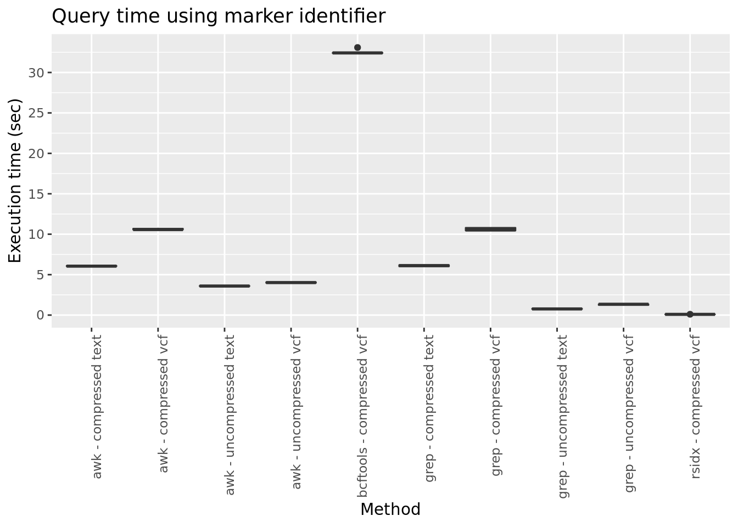

Mean query time (seconds; repetitions n=5) for extracting a single variant using the dbSNP identifier from summary statistics stored in tab-separated text or VCF. AWK, grep, bcftools [23] and rsidx [24] were evaluated using uncompressed and GZIP/BGZIP [23] compressed files. Error bars represent the 95% confidence interval.

Figure 3. Performance comparison for querying summary statistics in plain text and VCF format using chromosome position

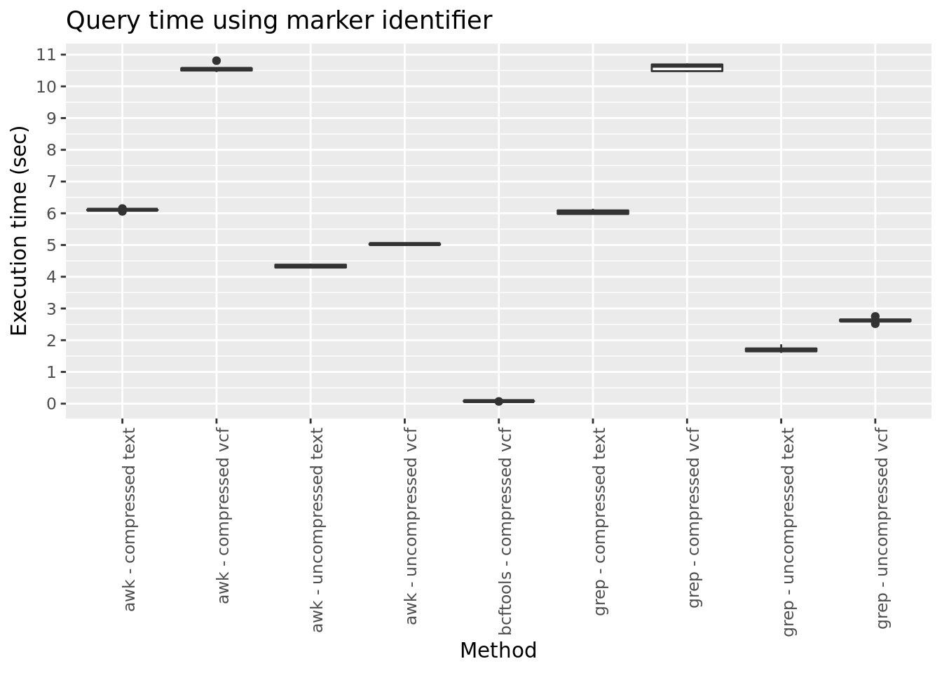

Mean query time (seconds; repetitions n=5) for extracting a single variant using chromosome position from summary statistics stored in tab-separated text or VCF. AWK, grep, and bcftools [23] were evaluated using uncompressed and GZIP/BGZIP [23] compressed files. Error bars represent the 95% confidence interval.

Figure 4. Performance comparison for querying summary statistics in plain text and VCF format using genomic interval

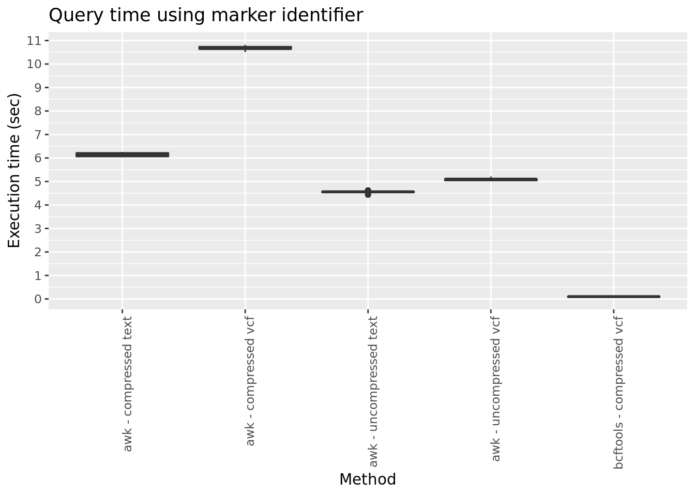

Mean query time (seconds; repetitions n=5) for extracting variants within a genomic interval using chromosome position from summary statistics stored in tab-separated text or VCF. AWK and bcftools [23] were evaluated using uncompressed and GZIP/BGZIP [23] compressed files. Error bars represent the 95% confidence interval.

Figure 5. Performance comparison for querying summary statistics in plain text and VCF format using trait association P value threshold

Mean query time (seconds; repetitions n=5) for extracting variants by trait association P value from summary statistics stored in tab-separated text, compressed VCF or compressed BCF. AWK and bcftools [23] were evaluated using uncompressed and GZIP/BGZIP [23] compressed files. Error bars represent the 95% confidence interval.

Supplementary Table 1. VCF header metadata fields for GWAS summary statistics

|  |  |  |
| --- | --- | --- |
| Field | Type | Description |
| TotalVariants | Integer | Total number of variants in input |
| VariantsNotRead | Integer | Number of variants that could not be read |
| HarmonisedVariants | Integer | Total number of harmonised variants |
| VariantsNotHarmonised | Integer | Total number of variants that could not be harmonised |
| SwitchedAlleles | Integer | Total number of variants strand switched |
| TotalControls | Integer | Total number of controls in the association study |
| TotalCases | Integer | Total number of cases in the association study |
| StudyType | String | Type of GWAS study [Continuous or CaseControl] |

Supplementary Table 2. VCF variant metadata fields for GWAS summary statistics using the SAMPLE fields

|  |  |  |
| --- | --- | --- |
| Field | Type | Description |
| ES | Float | Effect size estimate relative to the alternative allele |
| SE | Float | Standard error of effect size estimate |
| LP | Float | -log10 p-value for effect estimate |
| AF | Float | Alternate allele frequency in the association study |
| SS | Float | Sample size used to estimate genetic effect |
| EZ | Float | Z-score provided if it was used to derive the ES and SE fields |
| SI | Float | Accuracy score of summary data imputation |
| NC | Float | Number of cases used to estimate genetic effect |
| ID | String | Study variant identifier |

ES, effect size. SE, standard error. LP, log P value. AF, allele frequency. SS, sample size. EZ, effect Z-score. SI, summary imputation. NC, number of cases. ID, identifier.